There is currently logic in WDYM to default the Expected Receipt Date from the header level of the purchase order to all lines on the purchase order.

If I populate this field

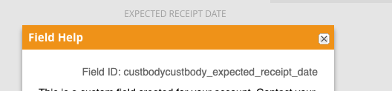

That date defaults to the expected receipt date field at the line level.

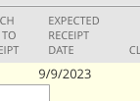

The current logic will update all the lines from the header when the purchase order is Saved AND when that expected receipt date at the header is updated. This does not allow the user to control the expected receipt date at the line level.

Here are the changes we want to make:

* There are actually two Expected Receipt Date fields at the header level of the purchase order form. We want to update the form so these fields are no longer displayed (I already hid ‘expected receipt date (2)’ and left the other exposed that has the logic for the existing script. Once you remove the script logic from that field you can hide that field).

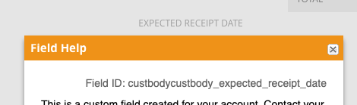

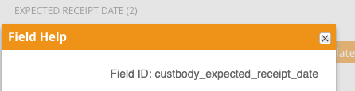

* We moved the Ex Factory date field to be just above the Receive By Date field.

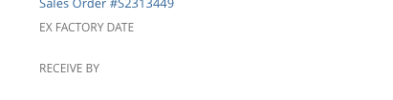

* We need to remove the existing logic that defaults the Expected Receipt date from the header to the line.
* We need to create the following logic:
  + Create a custom checkbox field titled ‘Run Date Updates’. If this box is checked, then the logic detailed below will initiate on Update. If this box is not checked, then it will only run on Create. The checkbox field should be next to the Ex Factory Date field.
  + The user will populate a date in the Ex Factory. When they enter this date and tab through the Ex Factory Date field, the Receive By date field directly below it (duedate) should be calculated as Ex Factory Date plus 8 weeks.
  + When the purchase order is saved, the date from the Receive By Date field (duedate) should default into the Expected Receipt Date field for all lines on the order. This should ONLY happen on Create and not on Edit/Update.
  + The user should have the ability to change/update the Expected Receipt Dates at the line level after the initial save (so they should be able to go in and edit the PO and update the expected receipt dates at the line level).